Computer Network Laboratory

CSN-361

Assignment 4

Name: Anshuman Shakya
Enrollment Number: 17114013
Class: 3rd year, B.Tech CSE

Problem Statement-

Q1- Write a Network Simulator (NS2) code to simulate a three node network with duplex links among them as shown in figure. Show the topology using NAM. Study the variation in number of packets dropped with the variation of the queue size in the nodes and with the variation of the bandwidth of the links.

Sol-

Approach-> Nodes communicate using the communication model that consists of Transport Control Protocol (TCP) agent, TCPSink agent, and Control Bit Rate (CBR) application. The sender node is attached to the TCP agent while the receiver node is attached to the TCPSink agent. The connection between TCP agent and TCPSink agent is established using the keyword “connect”. Transport agent (TCP) and application (CBR) are connected using the keyword “attach-agent”. TCP agent sends data to TCPSink agent.
The three node network is connected as follows:
Node 1 is connected with Node 2
Node 2 is connected with Node 3
Node 1 sends messages to Node 3 through Node 2.
The packets dropped depends on queue length and bandwidth.
As we increase the queue length of link 2-3 with the queue length of link 1-2 constant the packets drop decreases.
As we increase the bandwidth of link 2-3 with the bandwidth of link 1-2 constant the packets drop decreases.

Data Structure used->
ns2-Simulator class, TCP agents, CBR for simulating the topology in the Network Simulator Code.
Python library matplotlib.pyplot is used to plot the graphs-
queue length vs packets dropped
bandwidth vs packets dropped
Screenshots->
Simulation of the topology using NAM-
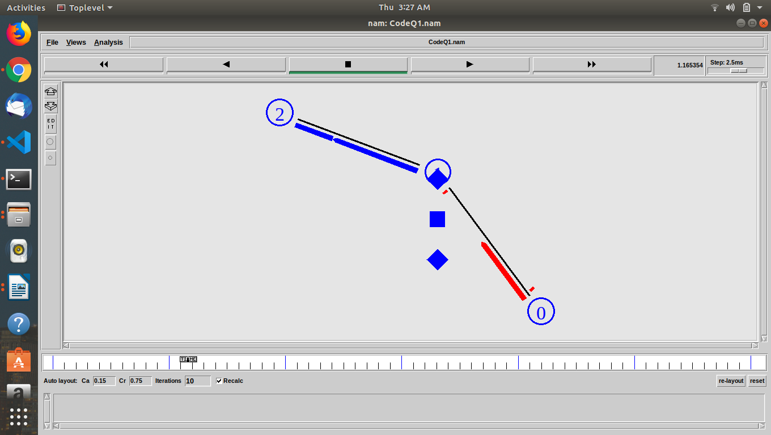
Variation in Queue length-
Constant Bandwidth- 1Mb
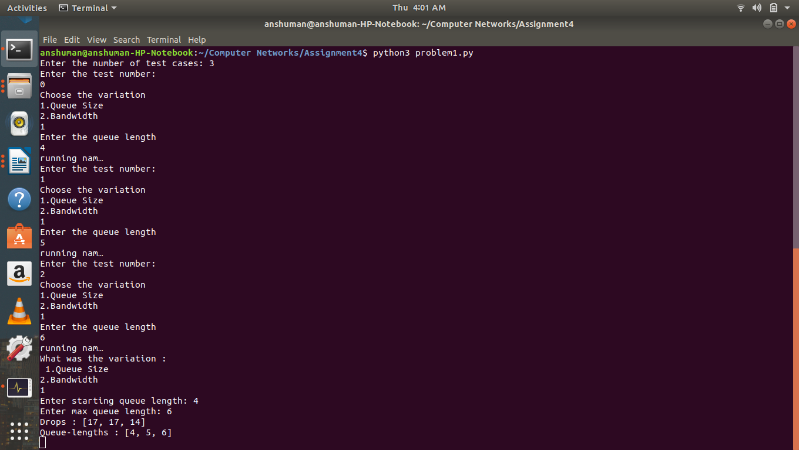

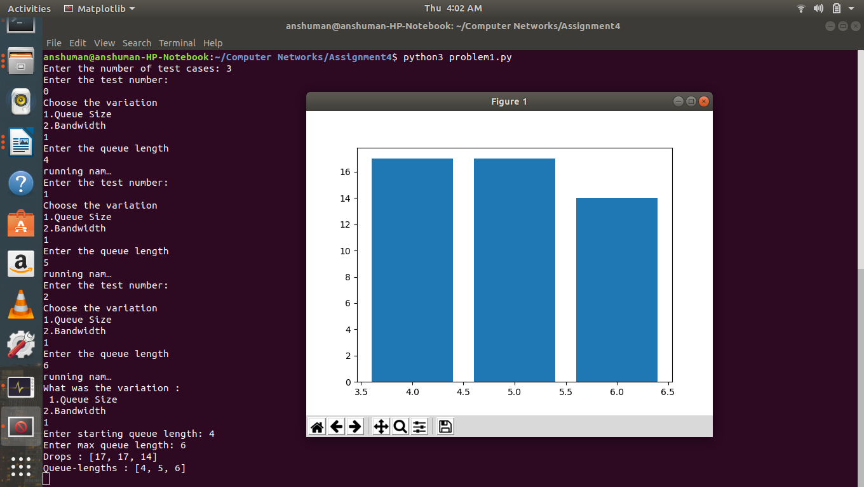
Variation in Bandwidth-
Constant Queue Length- 3
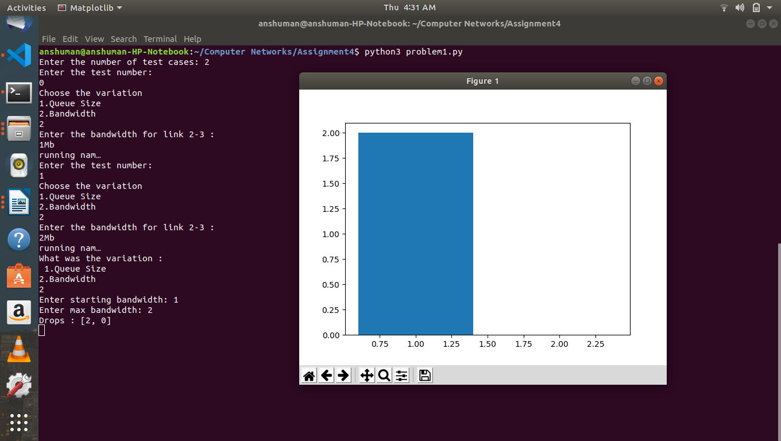

Q2- Write a Network Simulator (NS2) code to simulate the transmission of ping messages over a network topology consisting of 6 nodes and find the number of packets dropped due to congestion. Study the variation in number of packets dropped with the variation of the queue size in the nodes and with the variation of the bandwidth of the links.

Sol->

Approach->
An architecture of 6 nodes is created which are connected to each other like : 0-2, 1-2, 2-3, 3-4 and 3-5. Here, we pass ping messages of various packet sizes, from 0-4 and then from 5-1. I observe the changes in the drops as we vary the bandwidth and the queue lengths.
ping agents are attached to each of the node and specified their packet size. Then connected the ping agents which will act as endpoints in the communication of our messages. Bandwidths as well as the queue lengths are taken as parameters from the user.
In the tcl file, we will also store the inputs given by the user in a separate param file. We have a python script file which will make the tcl file to run and then after that will copy the contents of the bandwidth and the queue lengths into the list and then will analyze the trace files. Here, making a graph is too complex as we have 12 paramters and analayzing a graph of that dimension is difficult. So, instead we have made a table using plotly python library, that will display the the number of drops as we change the values of bandwidths and queue lengths.

Data Structure Used->

ns2-Simulator class
Ping Agent:
Ping is a basic Internet program that allows a user to verify that a particular IP address exists and can accept requests. Ping is used diagnostically to ensure that a host computer the user is trying to reach is actually operating. Ping works by sending an Internet Control Message Protocol (ICMP) Echo Request to a specified interface on the network and waiting for a reply. Ping can be used for troubleshooting to test connectivity and determine response time.

Recv():
The function 'recv()' defines the actions to be taken when a packet is received. Here it is used to print the ping message that the ping message is recieved in how much round trip time.

Screenshots->
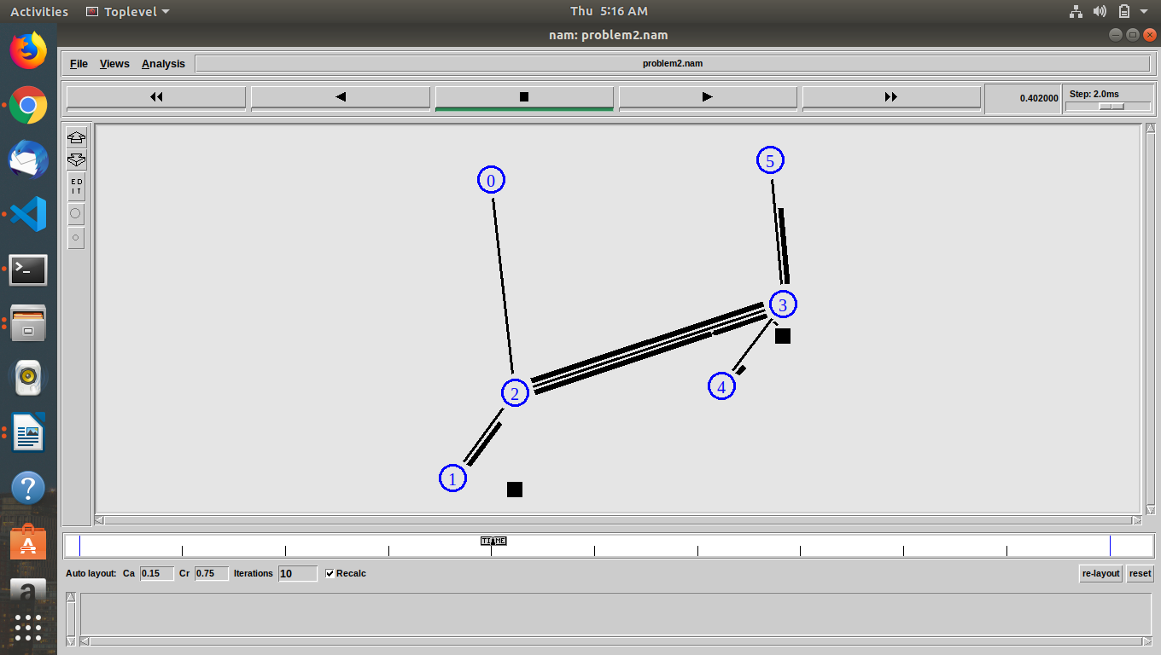

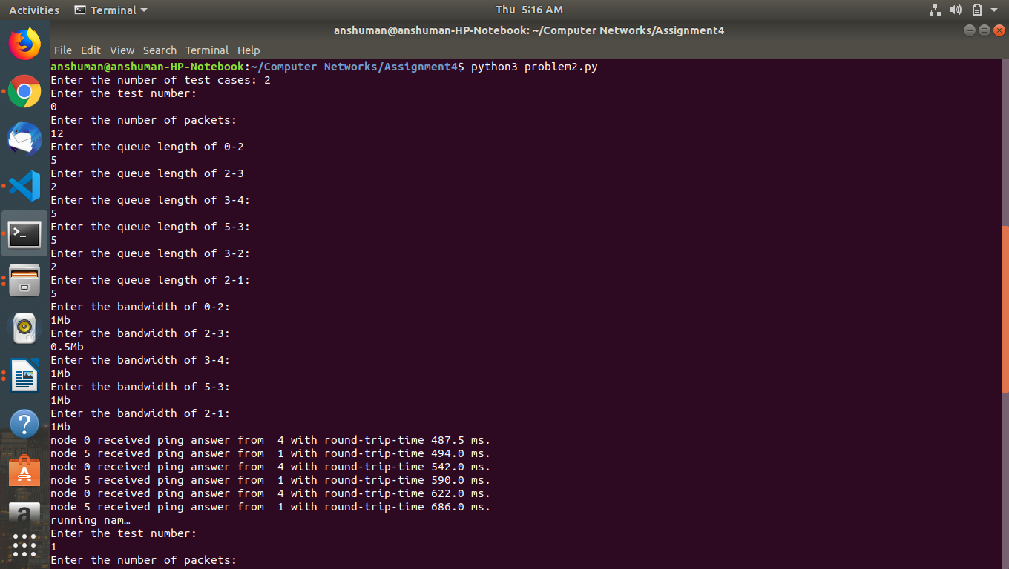

Table displaying the the number of drops as we change the values of bandwidths and queue lengths.
